

Love

Love is any of a number of emotions and experiences related to a sense of strong affection and attachment. The word love can refer to a variety of different feelings, states, and attitudes, ranging from generic pleasure ("I loved that meal") to intense interpersonal attraction ("I love my girlfriend"). This diversity of uses and meanings, combined with the complexity of the feelings involved, makes love unusually difficult to consistently define, even compared to other emotional states.



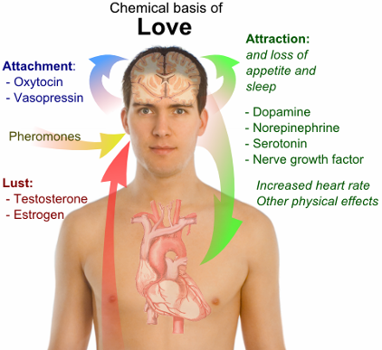

Biological models of sex tend to view love as a mammalian drive, much like hunger or thirst.[ Helen Fisher, a leading expert in the topic of love, divides the experience of love into three partly overlapping stages: lust, attraction, and attachment. Lust exposes people to others; romantic attraction encourages people to focus their energy on mating; and attachment involves tolerating the spouse (or indeed the child) long enough to rear a child into infancy.



I love you in many languages:

English - I love you
Danish- Jeg Elsker Dig
Finnish- Mina rakastan sinua
French - Je t'aime, Je t'adore
Irish - Taim i' ngra leat
Italian - Ti amo
Japanese - Aishiteru
German - Ich liebe dich
Polish - Kocham Ciebie
Portuguese - Eu te amo
Russian - Ya tebya liubliu
Greek - S'agapo
Slovak - Ľúbim ťa
Slovenian - Ljubim te
Spanish - Te quiero / Te amo
Swedish- Jag alskar dig
Czech - Miluji tě
Hawaiian - Aloha wau ia oi
Nórsky - Jeg Elsker Deg
Romanian - Te ubesk
Serbian - Volim te .....................

