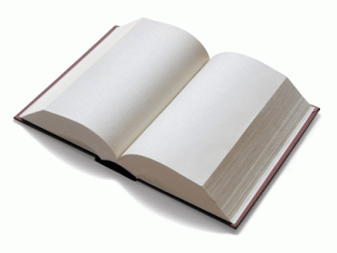
Books - reading

„Knowing I lov'd my books, he furnish'd me
From mine own library with volumes that
I prize above my dukedom.“
- William Shakespeare

A book is a set or collection of written, printed, illustrated, or blank sheets, made of paper, parchment, or other material, usually fastened together to hinge at one side. A single sheet within a book is called a leaf, and each side of a leaf is called a page. A book produced in electronic format is known as an e-book.
Books may also refer to a literature work, or a main division of such a work. In library and information science, a book is called a monograph, to distinguish it from serial periodicals such as magazines, journals or newspapers. The body of all written works including books is literature.

In novels, a book may be divided into several large sections, also called books (Book 1, Book 2, Book 3, etc).
A lover of books is usually referred to as a bibliophile, a bibliophilist, or a philobiblist, or, more informally, a bookworm.
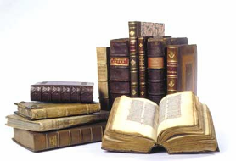
A store where books are bought and sold is a bookstore or bookshop. Books can also be borrowed from libraries or obtained for reading through the practice of Book Crossing.

Types of books according to their contents
A common separation by content are fiction and non-fictional books. By no means are books limited to this classification, but it is a separation that can be found in most collections, libraries, and bookstores.

Fiction
Many of the books published today are fictitious stories. They are in-part or completely untrue or fantasy. Historically, paper production was expensive; too expensive to be used for entertainment. An increase in global literacy and print technology led to the increased publication of books for the purpose of entertainment, and allegorical social commentary. Most fiction is additionally categorized by genre.

The novel is the most common form of fictional book. Novels are stories that typically feature a plot, setting, themes and characters. Stories and narrative are not restricted to any topic; a novel can be whimsical, serious or controversial. The novel has had a tremendous impact on entertainment and publishing markets.
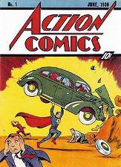
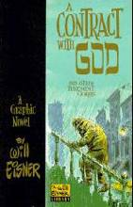
Comic books or graphic novels are books in which the story is told, but not illustrated, with pictures.

Non-fiction
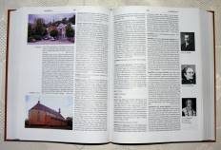
In a library, a general type of non-fiction book which provides information as opposed to telling a story, essay, commentary, or otherwise supporting a point of view, is often referred to as a reference book. A very general reference book, usually one-volume, with lists of data and information on many topics is called an almanac. An encyclopedia is a book or set of books designed to have more in-depth articles on many topics. A book listing words, their etymology, meanings, etc. is called a dictionary. A book which is a collection of maps is an atlas. A more specific reference book with tables or lists of data and information about a certain topic, often intended for professional use, is often called a handbook. Books which try to list references and abstracts in a certain broad area may be called an index, such as Engineering Index, or abstracts such as Chemical Abstracts, Biological Abstracts, etc.

An ancyclopedia

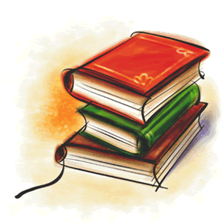
Books with technical information on how to do something or how to use some equipment are called instruction manuals. Other popular how-to books include cookbooks and home improvement books.
Students typically store and carry textbooks and schoolbooks for study purposes. Elementary school pupils often use workbooks which are published with spaces or blanks to be filled by them for study or homework. In higher education, is it common for a student to take an exam requiring a bluebook.
There is a large set of books that are made only to write private ideas, notes, and accounts. These type of books are rarely published and typically are destroyed or remain private. Notebooks are blank books to be written in by the user. Students and writers commonly use them for taking notes. Scientists and other researchers use lab notebooks to record their work. They often feature spiral coil bindings at the edge so that pages may easily be torn out.
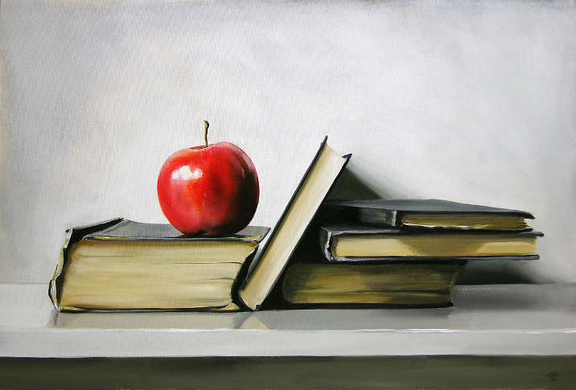
Address books, phone books, and calendar/appointment books are commonly used on a daily basis for recording appointments, meetings and personal contact information.
Books for recording periodic entries by the user, such as daily information about a journey, are called logbooks or simply logs. A similar book for writing daily the owner's private personal events, information, and ideas is called a diary or personal journal.
Businesses use accounting books such as journals and ledgers to record financial data in a practice called bookkeeping.

Other types
There are several other types of books which are not commonly found under this system. Albums are books for holding a group of items belonging to a particular theme, such as a set of photographs, card collections, and memorabilia. One common example are stamp albums, which are used by many hobbyists to protect and organize their collections of Postage stamps. Such albums are often made using removable plastic pages held inside in a ringed binder or other similar folder.
Hymnals are books with collections of musical hymns that can typically be found in churches. Prayerbooks or missals are books that contain written prayers and are commonly carried by monks, nuns, and other devoted followers or clergy.

History of books
Papyrus is a thick paper-like material produced from the pith of the papyrus plant, Cyperus papyrus, a wetland sedge that was once abundant in the Nile Delta of Egypt.
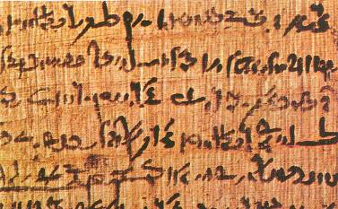
Papyrus usually grow 2–3 meters (5–9 ft) tall. Papyrus is first known to have been used in ancient Egypt (at least as far back as the First dynasty), but it was also used throughout the Mediterranean region. Ancient Egypt used this plant for boats, mattresses, mats, and paper.

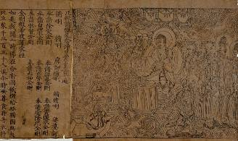
Woodblock printing is a technique for printing text, images or patterns used widely throughout East Asia and originating in China in antiquity as a method of printing on textiles and later paper. As a method of printing on cloth, the earliest surviving examples from China date to before 220, and from Egypt to the 4th century. Ukiyo-e is the best known type of Japanese woodblock art print. Most European uses of the technique on paper are covered by the art term woodcut, except for the block-books produced mainly in the fifteenth century.

-The intricate frontispiece of the Diamond Sutra from Tang Dynasty China, 868 AD (British Museum)


Modern world
Steam-powered printing presses became popular in the early 1800s. These machines could print 1,100 sheets per hour, but workers could only set 2,000 letters per hour.
Monotype and linotype presses were introduced in the late 19th century. They could set more than 6,000 letters per hour and an entire line of type at once.
The centuries after the 15th century were thus spent on improving both the printing press and the conditions for freedom of the press through the gradual relaxation of restrictive censorship laws. See also intellectual property, public domain, copyright. In mid-20th century, Europe book production had risen to over 200,000 titles per year.

Použitá literatúra:
http://en.wikipedia.org/wiki/William_Shakespeare
http://www.jstor.org/pss/20024803
http://scholar.google.sk/scholar?hl=sk&lr=&newwindow=1&cites=15315244414029113288

