
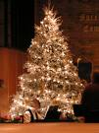



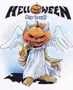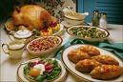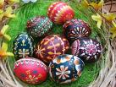

The US and UK share many of the same holidays and most are celebrated in similar fashions, such as New Years, Easter, Halloween, and Christmas to name a few.

The UK also has a number of holidays that the US has carried over, such as St. Patrick’s Day and others that are rather unheard of in the United States, such as Boxing Day, Guy Fawkes Nights, Burns Night, St. George’s Day, St. David’s Day, St. Andrew’s Day and Pancake Day.

Valentine’s Day

Valentine's Day or Saint Valentine's Day is a holiday celebrated on February 14 by many people throughout the world. In the West, it is the traditional day on which lovers express their love for each other by sending Valentine's cards, presenting flowers, or offering confectionery. The holiday is named after two among the numerous Early Christian martyrs named Valentine. The day became associated with romantic love in the circle of Geoffrey Chaucer in the High Middle Ages, when the tradition of courtly love flourished.An alternative theory from Belarus states that the holiday originates from the story of Saint Valentine, who upon rejection by his mistress was so heartbroken that he took a knife to his chest and sent her his still-beating heart as a token of his undying love for her. Hence, heart-shaped cards are now sent as a tribute to his overwhelming passion and suffering.

Mother’s Day 
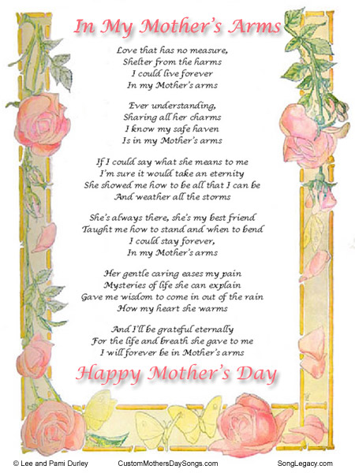
Mother's Day is a day honoring mothers, celebrated on various days in many places around the world. It complements Father's Day, the celebration honoring fathers.
It is a relatively modern concept, not to be confused with the 16th century celebration of Mothering Sunday.

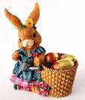
Easter
Easter is the most important religious feast in the Christian liturgical year. Christians believe that Jesus was resurrected from the dead three days] after his crucifixion, and celebrate this resurrection on Easter Day, or Easter Sunday, two days after Good Friday. The year of his death and resurrection is variously estimated between the years 26 and 36 AD (see also Chronology of Jesus).
Easter also refers to the season of the church year called Eastertide or the Easter Season. Traditionally the Easter Season lasted for the forty days from Easter Day until Ascension Day but now officially lasts for the fifty days until Pentecost. The first week of the Easter Season is known as Easter Week or the Octave of Easter. Easter also marks the end of Lent, a season of prayer and penance.
Easter is termed a moveable feast because it is not fixed in relation to the civil calendar. Easter falls at some point between late March and late April each year (early April to early May in Eastern Christianity), following the cycle of the moon. After several centuries of disagreement, all churches accepted the computation of the Alexandrian Church (now the Coptic Church) that Easter is the first Sunday after the Paschal Full Moon, which is the first moon whose 14th day (the ecclesiastic "full moon") is on or after March 21 (the ecclesiastic "vernal equinox").
Easter is linked to the Jewish Passover not only for much of its symbolism but also for its position in the calendar.


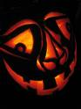 Helloween
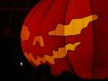
Helloween are a German power/speed metal band founded in the mid 1980s by members of Iron Fist and Powerfool. The band is known as one of the pioneering power metal bands, being part of the German heavy/speed/power metal scene that included Accept, Running Wild, Grave Digger, Sinner, and Rag
Thanksgiving
Thanksgiving Day is a harvest festival. Traditionally, it is a time to give thanks for the harvest and express gratitud in general. It is a holiday celebrated primarily in Canada and the United States. While perhaps religious in origin, Thanksgiving is now primarily identified as a secular holiday.
The date and location of the first Thanksgiving celebration is a topic of modest contention. Though the earliest attested Thanksgiving celebration was on September 8, 1565 in what is now Saint Augustine, Florida, the traditional "first Thanksgiving" is venerated as having occurred at the site of Plymouth Plantation, in 1621.
Today, Thanksgiving is celebrated on the second Monday of October in Canada and on the fourth Thursday of November in the United States. Thanksgiving dinner is held on this day, usually as a gathering of family members and friends.

Christmas
Christmas also referred to as Christmas Day, is an annual holiday celebrated on December 25 or January 7 that commemorates the birth of Jesus of Nazareth. The day marks the beginning of the larger season of Christmastide, which lasts twelve days The nativity of Jesus, which is the basis for the anon Dominic system of dating, is thought to have occurred between 7 and 2 BC.^{[5]} December 25 is not thought to be Jesus' actual date of birth, and the date may have been chosen to correspond with either a Roman festival or with the winter solstice.Modern customs of the holiday include gift-giving, Church celebrations, and the display of various decorations including the Christmas tree, lights, mistletoe, nativity scenes, and holly. Santa Claus (also referred to as Father Christmas, although the two figures have different origins) is a popular mythological figure often associated with bringing gifts at Christmas for children. Santa is generally believed to be the result of a concretization between Saint Nicholas and elements from pagan Nordic and Christian mythology, and his modern appearance is believed to have originated in 19th century media.
Christmas is celebrated throughout the Christian population, but is also celebrated by many non-Christians as a secular, cultural festival. Because gift-giving and several other aspects of the holiday involve heightened economic activity among both Christians and non-Christians, Christmas has become a major event for many retailers.
Boxing Day ( December 26) is so- called because it is time when tradespeople receive a Christmas box- some money in a appreciation of the work they’ve carried out all year.
Traditionality it is a time for visiting family and friends and indulging in more feasting, Boxing Day is a popular day for football matches and other sporting eventrs.

New Year
The New Year is an event that happens when a culture celebrates the end of one year and the beginning of the next year. Cultures that measure yearly calendars all have New Year celebrations.
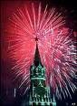
Wikipédia – Slobodná encyklopédia.[online], [citované 01. 01. 2009]. Dostupné na internete:
< http://en.wikipedia.org/wiki/English>

